CSE 113 Homework 1

Report

Producer-consumer Queues
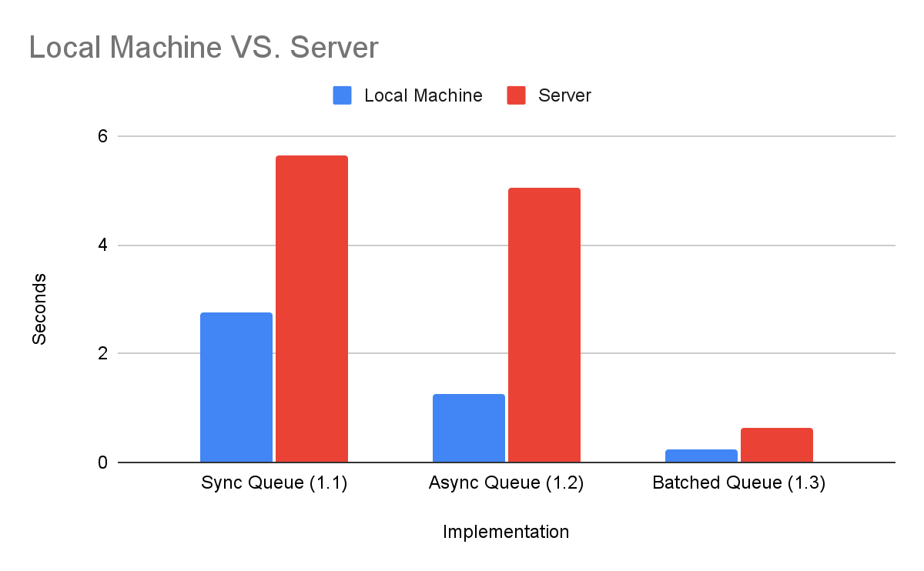
Implementation | Local Machine | Server
Sync Queue (1.1) | 2.75016 | 5.62675
Async Queue (1.2) | 1.24513 | 5.04348
Batched Queue (1.3) | 0.234106 | 0.648953

For the synchronous queue, I implemented a handoff mechanism using two atomic booleans where the producer spins until the consumer is ready and vice versa, enforcing a strict one-at-a-time exchange as discussed in lecture. For the asynchronous queue, I used a circular buffer of size 2048 with two monotonically increasing atomic integers for head and tail, where size is simply tail minus head which avoids any wraparound edge cases. For the batched version, I extended the async queue with enq_8 and deq_8 functions that check for 8 available slots or items before proceeding and advance the head or tail by 8 atomically after completing the batch. One challenge I ran into was a data race flagged by ThreadSanitizer between the load and store threads sharing the same array, which I resolved using __atomic_load_n and __atomic_store_n with SEQ_CST ordering since the atomic builtins don't natively support floats, requiring a memcpy to reinterpret the bits safely.
Something really interesting from the results is just how dramatic the improvement from batching was on the server, the batched queue ran at 0.65 seconds compared to 5.04 seconds for async and 5.63 seconds for sync, which is roughly an 8-9x speedup over async alone. I didn't expect the gap to be that large. On my local machine the pattern held the same with sync at 2.75 seconds, async at 1.25 seconds, and batched at just 0.23 seconds. The async queue being faster than sync makes intuitive sense since the async queue allows the producer to keep filling the buffer without waiting for each individual dequeue, reducing idle spinning time. The batch improvement is even more significant because it reduces the number of total enqueue and dequeue operations by a factor of 8, which means far fewer atomic operations and less synchronization overhead overall. The server showed a bigger relative gap between sync and async than local, which could be due to the server having more cores and thus more contention on individual atomic operations in the synchronous case.

DOALL Loop Parallel Schedules

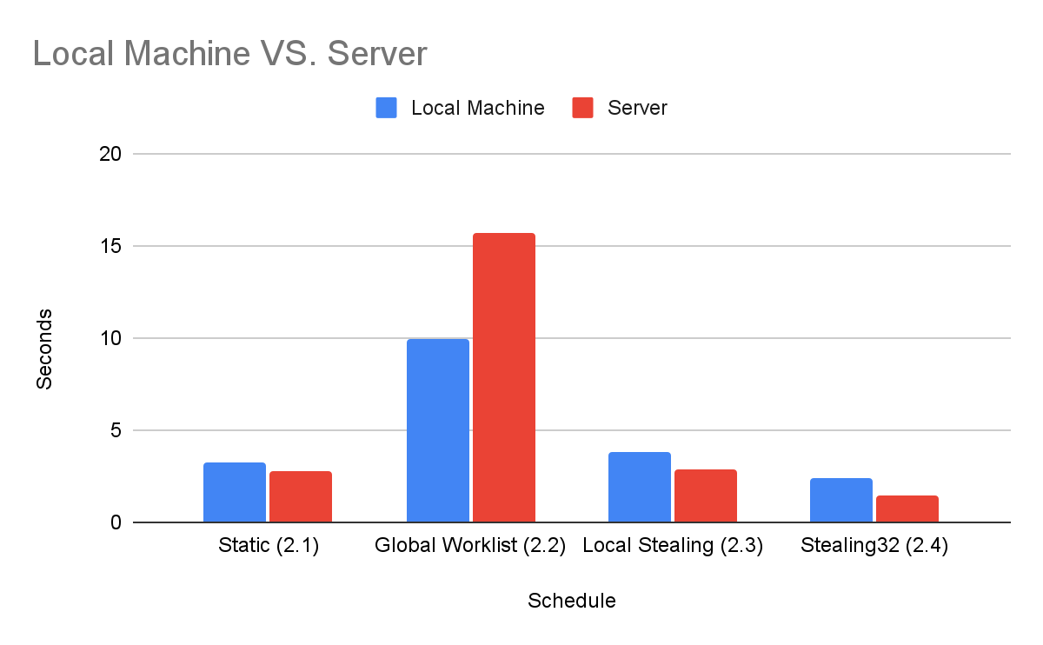
Implementation | Local Machine | Server
Static (2.1) | 3.228 | 2.74078
Global Worklist (2.2) | 9.98169 | 15.6648
Local Stealing (2.3) | 3.77172 | 2.84558
Stealing32 (2.4) | 2.37955 | 1.49057

For the static schedule, I split the index space into contiguous chunks where thread 0 gets indices 0 through size/num_threads and each subsequent thread gets the next chunk, which is straightforward but creates load imbalance since linear_work assigns more work to higher indices. For the global worklist, I replaced the static partition with a shared atomic counter where each thread does a fetch_add to claim the next index, naturally load balancing but creating contention on that single counter. For the local worklist, I implemented an IOQueue with atomic head and tail pointers that supports either parallel enqueues or parallel dequeues but not both simultaneously, then initialized each thread's queue with a chunked range before launching the computation phase where threads drain their own queue first and steal from others when empty. For stealing32, I extended deq_32 to atomically claim 32 indices at once with a single fetch_add and roll back if 32 weren't available, then updated the computation threads to process batches of 32 at a time.
The most surprising result by far was how slow the global worklist was 9.98 seconds locally and 15.66 seconds on the server, which is actually slower than single threaded static in some cases. I didn't expect the atomic counter contention to be that severe, but with 8 threads all hammering the same atomic variable for every single index it makes sense that the overhead dominates. The static schedule performed reasonably well at 3.23 seconds locally and 2.74 seconds on the server despite the load imbalance, which suggests that for this particular workload the imbalance isn't catastrophic enough to kill performance entirely. The local stealing was a big improvement over global at 3.77 seconds locally and 2.85 seconds on the server since each thread mostly works from its own queue and only uses atomic operations when stealing. The stealing32 results were the best overall at 2.38 seconds locally and 1.49 seconds on the server, which mirrors the batching improvement we saw in part 1, fewer atomic operations for the same amount of work means less synchronization overhead and better throughput. The server consistently outperformed local for stealing and stealing32, likely because it has more physical cores that can truly run in parallel without sharing resources.

Design Document

Producer-consumer Queues
For the synchronous queue, my thought process was to keep it as simple as possible and stick to what was discussed in lecture. I used two atomic booleans, one to signal that an item is ready to be consumed and one to prevent the producer from overwriting before the consumer picks it up. The producer spins until the consumer clears the flag, and vice versa, enforcing the one-at-a-time handoff. The hardest part was getting the ordering of the flag updates right so that neither thread could race past the other. For the asynchronous queue, I used a circular buffer with two atomic integers for the head and tail. Rather than storing modulo indices directly, I kept them as monotonically increasing integers and only applied the modulo when indexing into the buffer, which made the size calculation trivially correct as just tail minus head. The trickiest part here was the size check for enq_8 and deq_8, since I needed to check for 8 slots of space or 8 items available rather than just 1, which required a slightly different condition than the single element case.
For the synchronous queue in CQueueSync.h, my thought process was to keep it simple and stick closely to what was discussed in lecture. I used two atomic booleans has_item and waiting_for_deq to coordinate the handoff between producer and consumer. The producer first spins until the previous item has been consumed, then writes the item and sets both flags. The consumer spins until has_item is true, reads the value, and clears the flag. The ordering of these flag updates was the trickiest part since getting them wrong would cause either a deadlock or a race where the producer overwrites before the consumer reads. The key insight was that the producer needs to wait on two conditions: first that the consumer is ready, and second that the consumer has actually picked up the item after it was placed.
For the asynchronous queue in CQueue.h, I used a circular buffer of size CQUEUE_SIZE with two atomic integers for head and tail. Rather than storing the indices already reduced by modulo, I kept them as monotonically increasing integers and only applied the modulo when indexing into the buffer. This made the size calculation trivially correct as just tail - head, which avoids any wraparound edge cases. The producer spins while the buffer is full (size == CQUEUE_SIZE) and the consumer spins while it is empty (size == 0). For enq_8 and deq_8, the size check is slightly more involved. I had to check for 8 available slots or 8 available items rather than just 1 before proceeding, and then atomically advance the head or tail by 8 after writing or reading the batch. This ensures that neither the producer nor consumer ever partially completes a batch operation.
For part3_thread_funcs.h, I adapted the single-element thread functions from main.cpp to operate in batches of 8. Each function uses a local batch array, loads or stores 8 elements at a time, and calls enq_8 or deq_8 accordingly. One challenge that came up during testing was a data race flagged by ThreadSanitizer between the memory load thread reading from array a and the memory store thread writing back to the same array. Even though the pipeline ordering through the queues logically prevents them from ever touching the same index simultaneously, TSan cannot prove this. I resolved this by using __atomic_load_n and __atomic_store_n with __ATOMIC_SEQ_CST memory ordering, using memcpy to safely reinterpret the float bits as integers since the atomic builtins only natively support integer types. This made the synchronization relationship explicit enough for TSan to accept.

DOALL Loop Parallel Schedules
My approach was to build each part incrementally on top of the last, similar to how the assignment was structured. For the static schedule, I divided the index space into contiguous chunks and assigned each thread its own range, which was straightforward but I knew going in that it would have load imbalance since higher indices do more work. For the global worklist, I replaced the static partition with an atomic counter that each thread increments to grab the next index, which naturally load balances but creates contention on the counter itself. For the local worklist workstealing, I initialized each thread's IOQueue with its own chunk of indices in a parallel enqueue phase, then had threads drain their own queue first before stealing from others. The IOQueue itself needed careful design since it only supports parallel enqueues or parallel dequeues but not both simultaneously, so I used atomic head and tail pointers accordingly. The deq_32 extension for part 4 was the same idea but atomically claimed 32 indices at a time, reducing the overhead from repeated atomic operations and improving performance noticeably.
For the static schedule in part1_static.h, I divided the total index space into contiguous chunks and assigned each thread a range from tid * chunk to (tid+1) * chunk. The last thread gets any remaining indices in case SIZE is not perfectly divisible by NUM_THREADS. Each thread then independently runs the inner multiplication loop for its assigned indices. This was straightforward to implement but I knew going in it would have load imbalance. Because linear_work assigns more work to higher indices, the last thread does significantly more work than the first, leaving earlier threads idle while the last thread finishes.
For the global worklist in part2_global.h, I replaced the static partition with a single shared atomic counter initialized to 0. Each thread repeatedly increments the counter with fetch_add(1) to claim the next available index, stopping when the counter reaches SIZE. This naturally load balances since busy threads simply claim fewer indices. The downside is that every index claim requires an atomic operation on a shared variable, which creates contention as the number of threads increases. This is visible in the timing results where global is actually slower than static due to that overhead.
For the local worklist in part3_local.h, I first implemented IOQueue.h as an input/output queue that supports either parallel enqueues or parallel dequeues but not both at the same time. I used atomic head and tail pointers with a dynamically allocated buffer. The enqueue atomically increments tail and writes to that slot, and the dequeue atomically increments head and checks if it went past tail, rolling back if the queue was empty. In part3_local.h, I first launch threads in parallel to initialize each thread's local queue with a chunked range of indices, similar to the static schedule. After joining those threads, I launch the actual computation threads which drain their own queue first and then steal from other threads' queues when their own is empty. This combines the predictability of chunked initialization with the load balancing benefit of stealing.
For part4_local32.h, I implemented deq_32 in IOQueue.h which atomically claims 32 indices at once by doing a single fetch_add(32) on head and then checking if there were actually 32 elements available, rolling back if not. The parallel_mult function then dequeues 32 indices at a time and processes them in a loop. The benefit here is that each thread makes far fewer atomic operations to process the same amount of work, reducing the overhead that was visible in the single-element stealing version and explaining the improved timing results.

